**Rohit Bokil VCS Homework**

**Exercise 1**

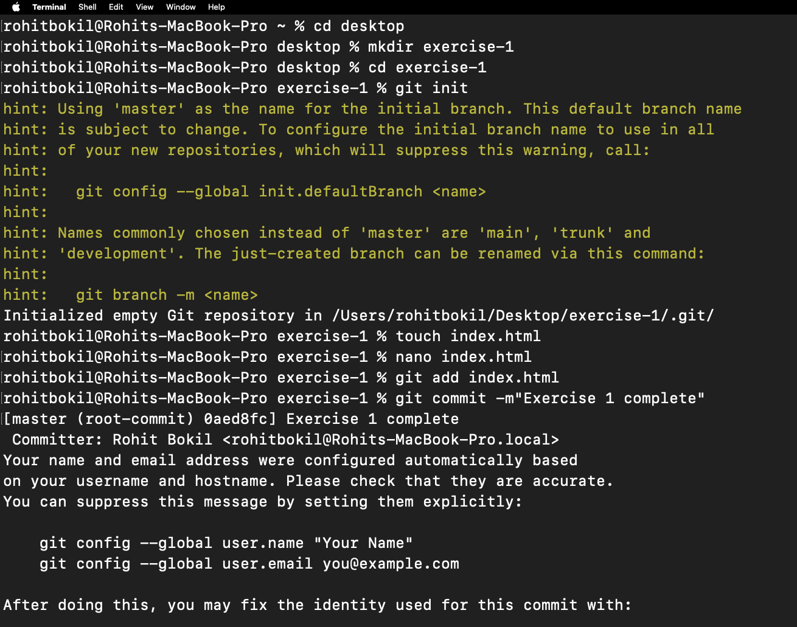

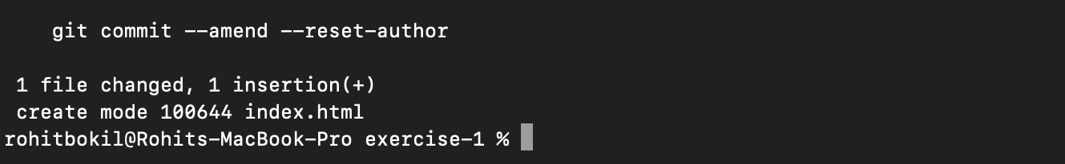

**Exercise 2**

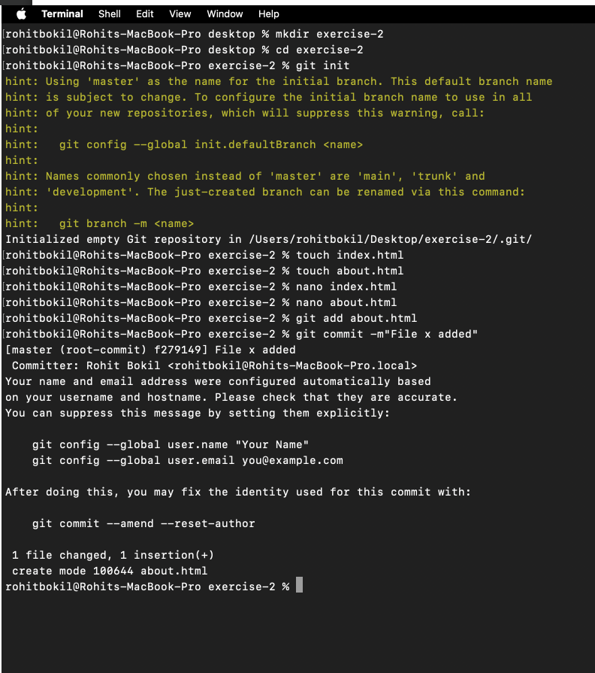

**Exercise 3**

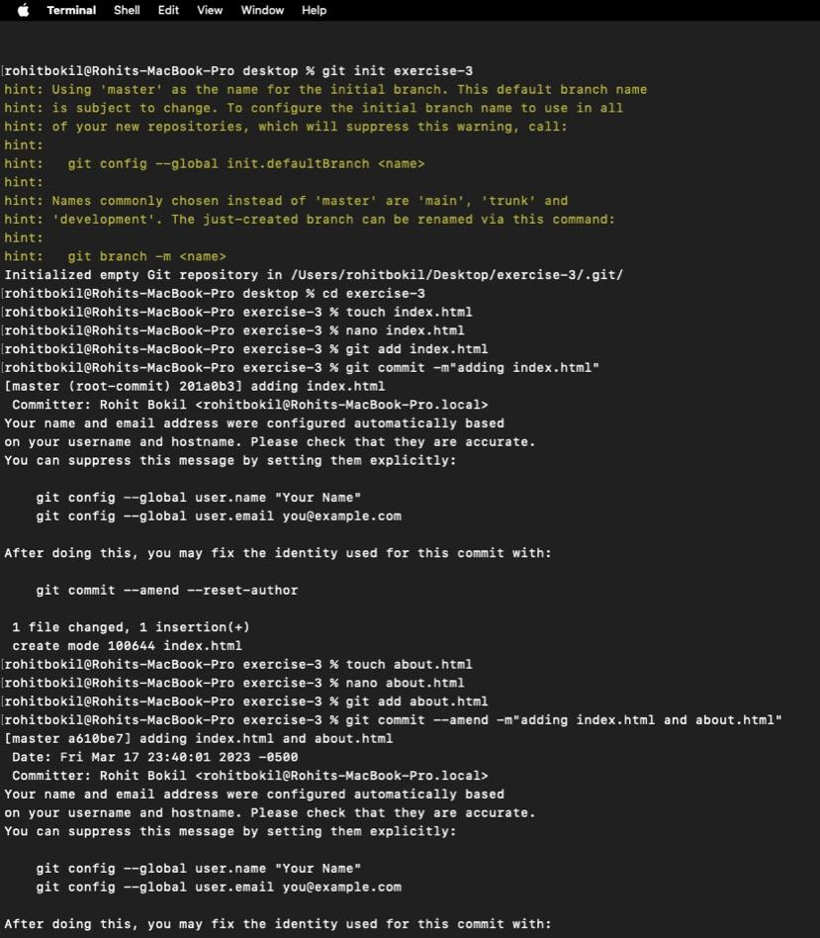

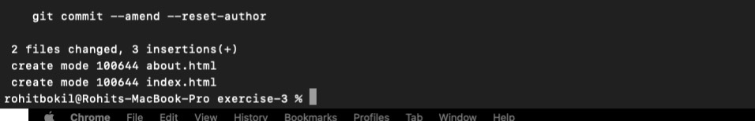

**Exercise 4**

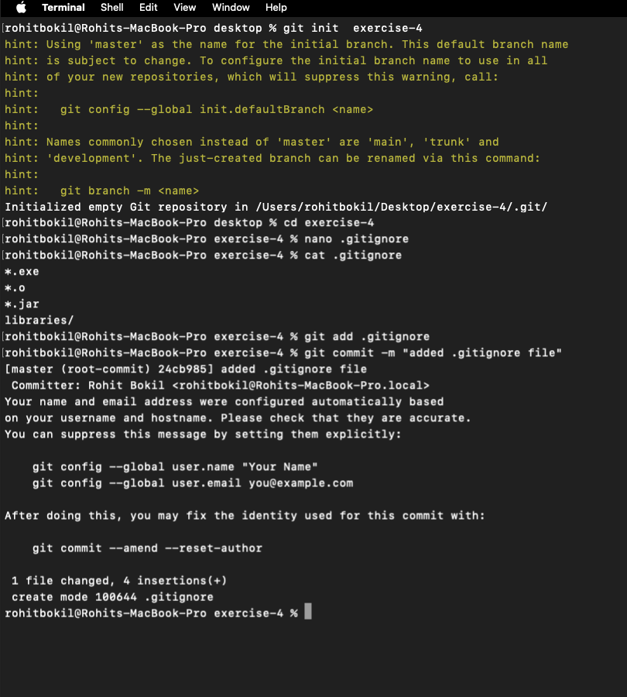

**Exercise 5**

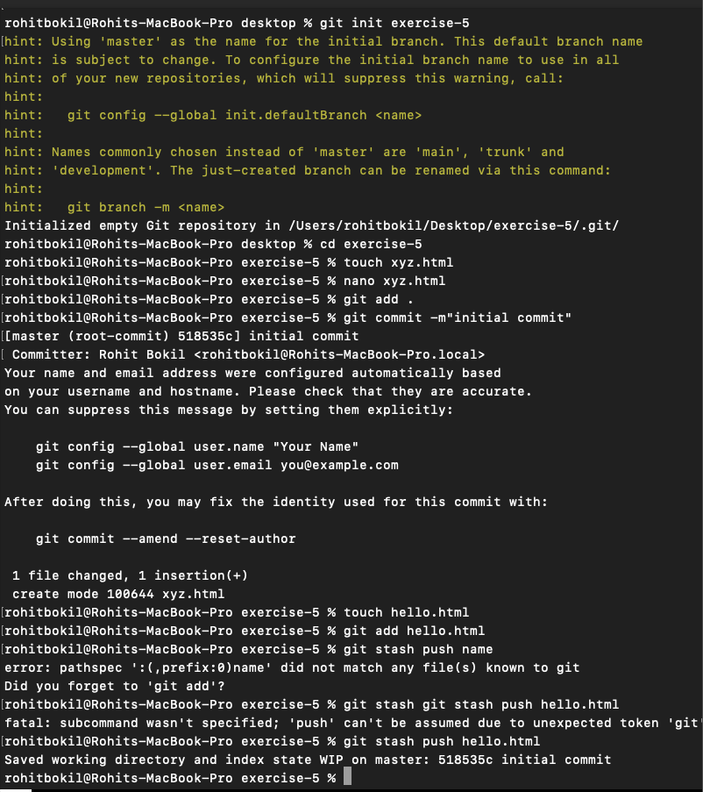

**Exercise 6**

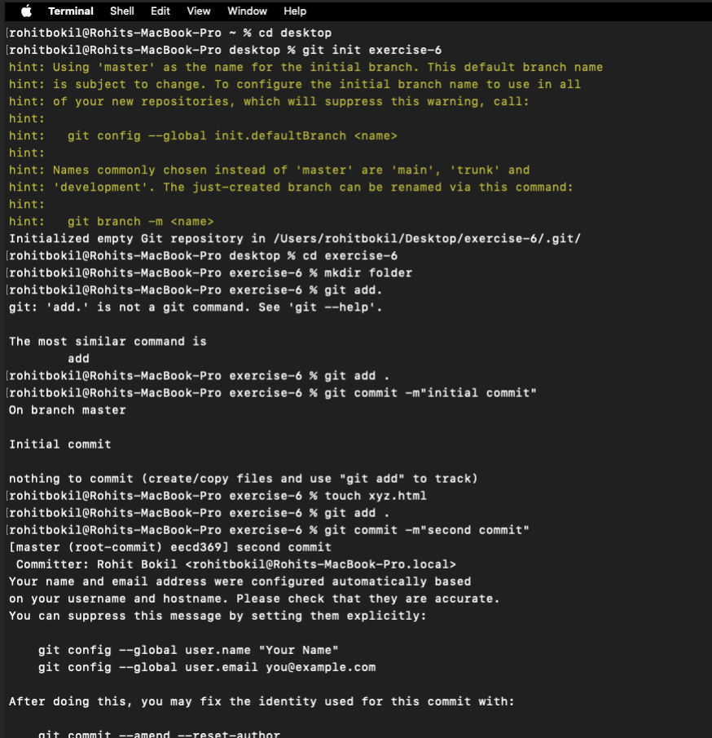

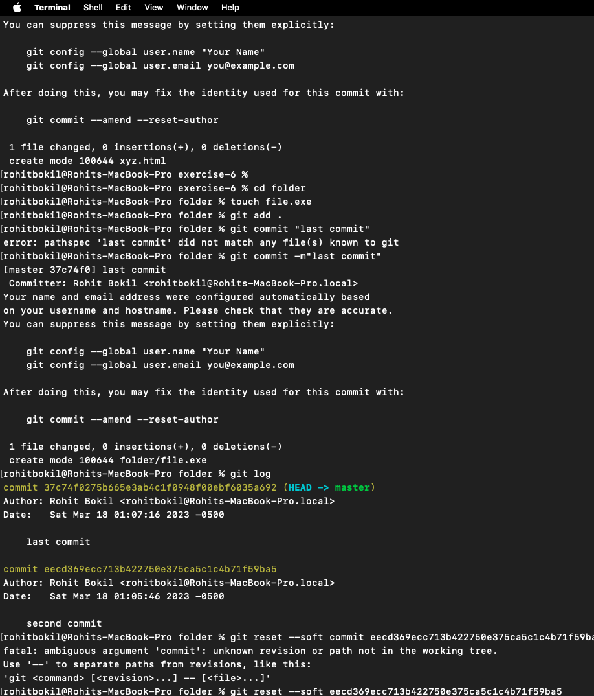

**Exercise 7**

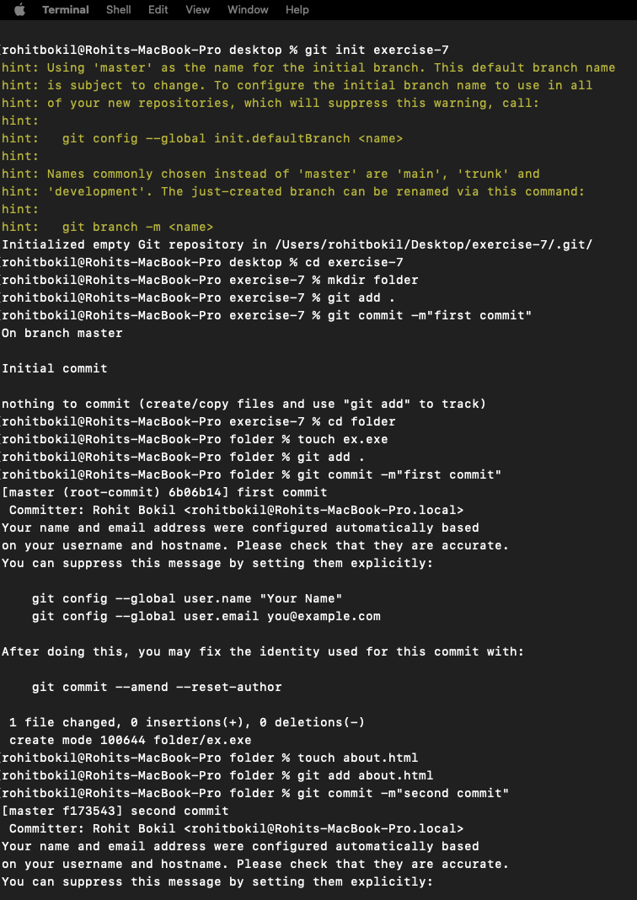

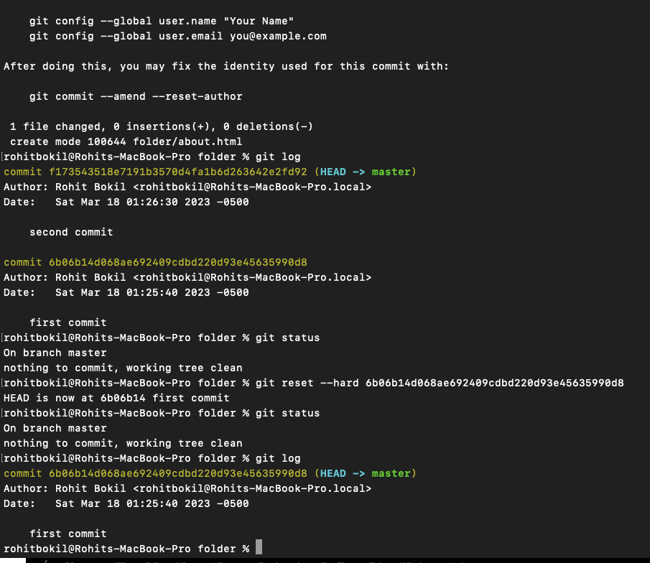

**Exercise 8**

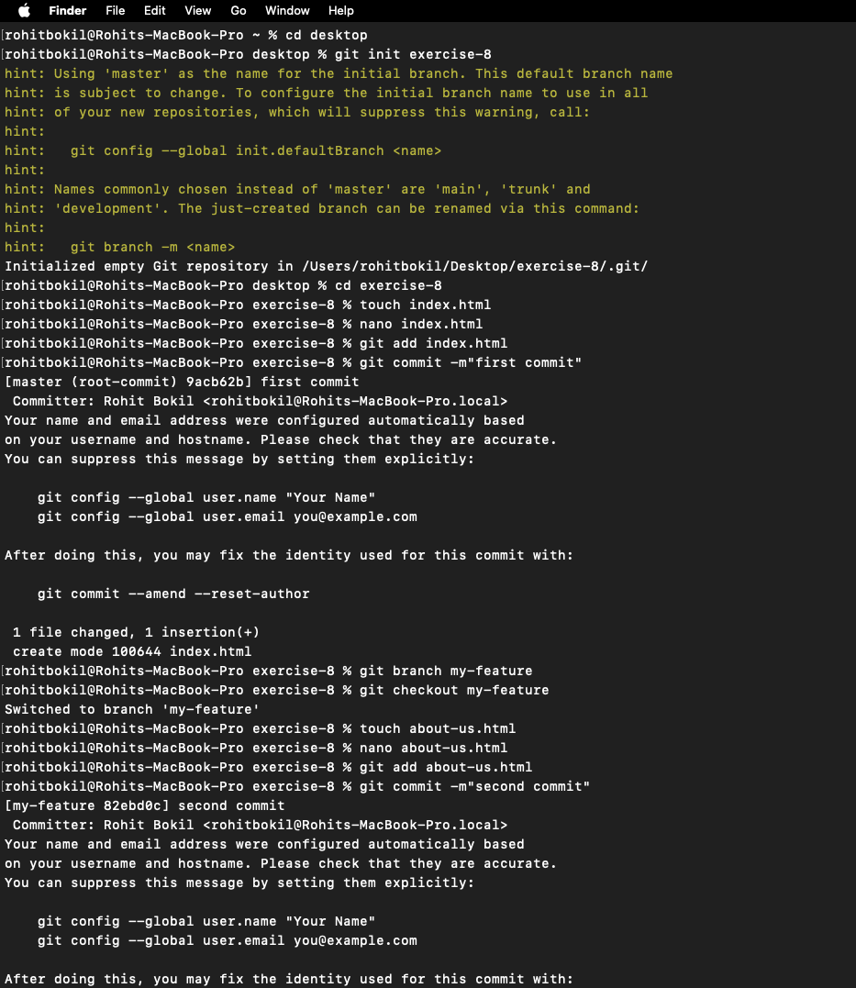

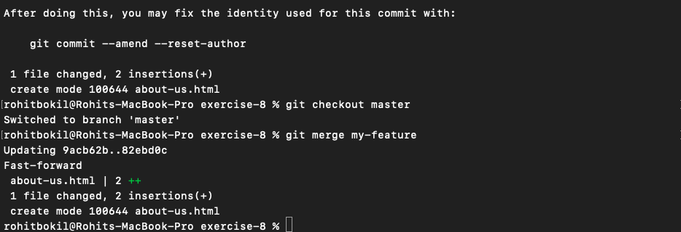

**Exercise 9**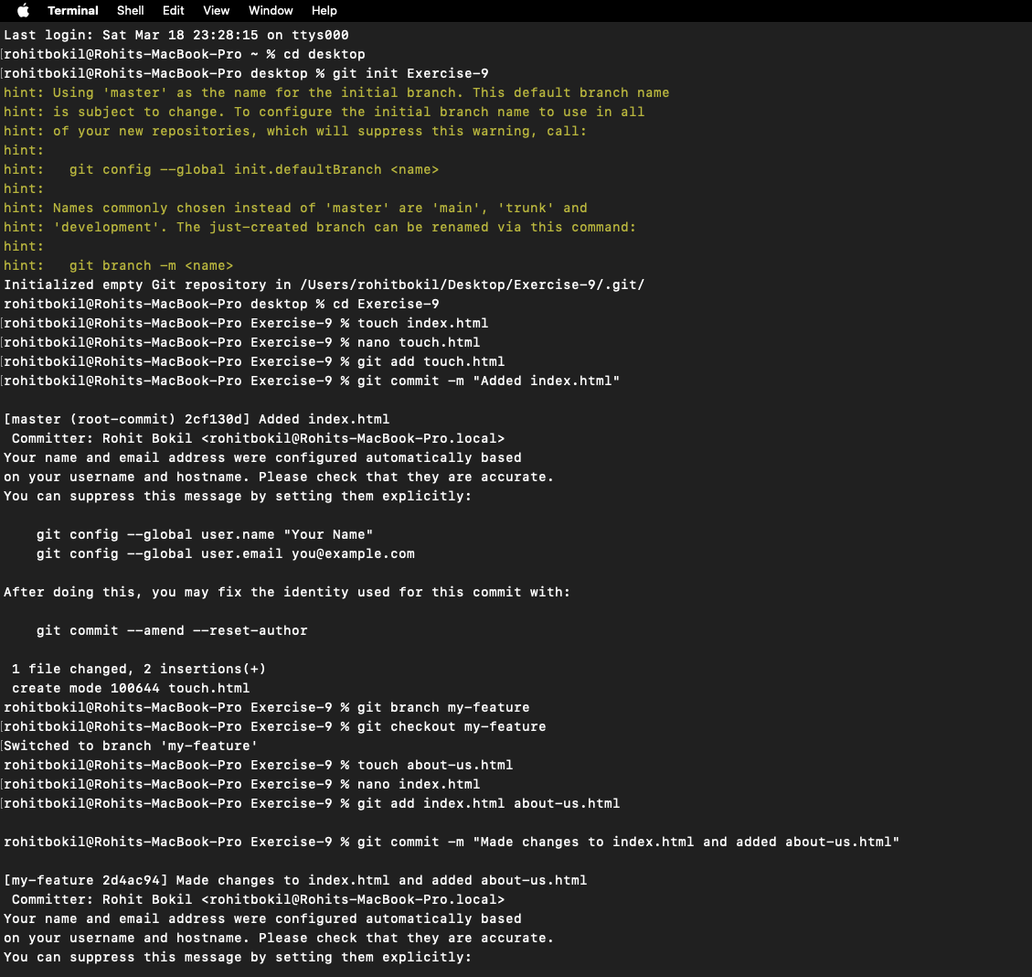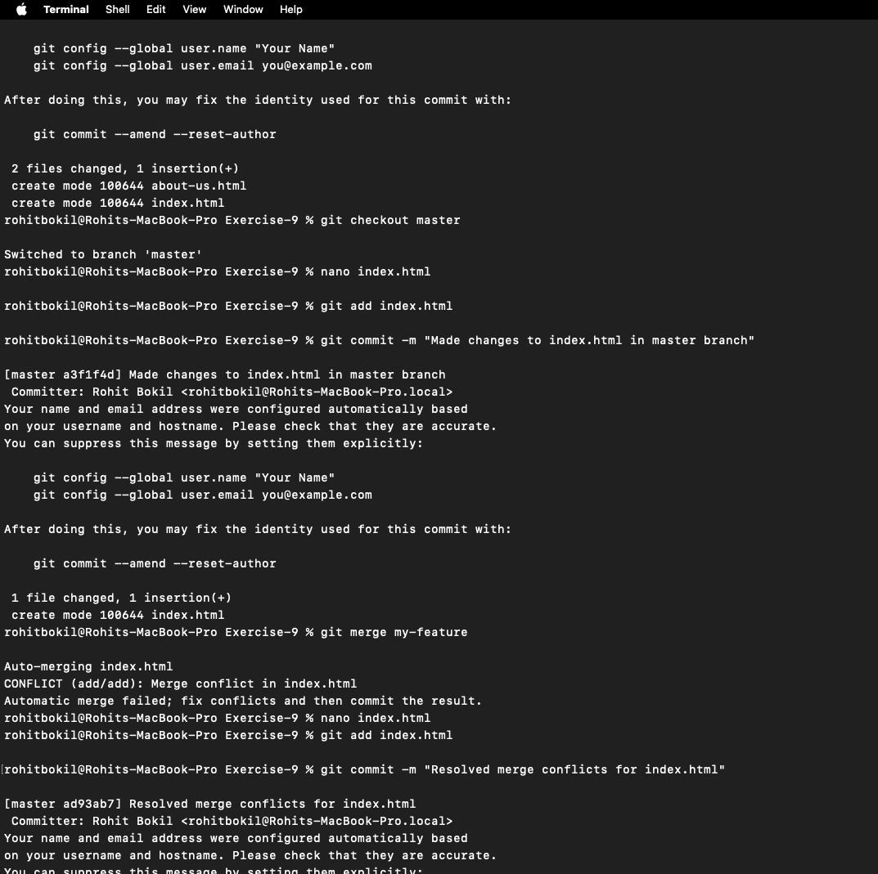

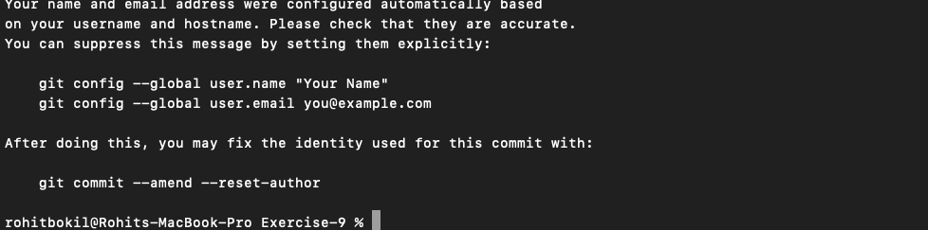

**Repo link on git hub**

[**https://github.com/Rohitkacode/exercise-3**](https://github.com/Rohitkacode/exercise-3)

**https://github.com/Rohitkacode/exercise-4**

[**https://github.com/Rohitkacode/exercise-8**](https://github.com/Rohitkacode/exercise-8)

**https://github.com/Rohitkacode/Exercise_9**